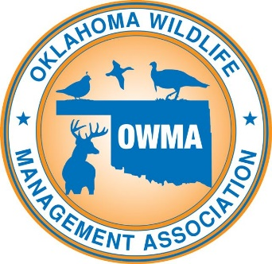

NEWS RELEASE
For immediate release – April 17, 2021

Conservation Organization Sponsors Sporting Clay Event
ARDMORE, Okla.—The Oklahoma Wildlife Management Association (OWMA) will sponsor a sporting clay event on June 5 at the Side X Side Ranch, located at 41998 E. County Road 1600 near Wynnewood, Oklahoma.

Registration opens at 8 a.m., and a mandatory safety meeting will begin at 8:45 a.m. Competition shooting will occur from 9 a.m.-noon. Lunch will be provided for participants with awards distributed during or after lunch.

“This event is a great way for people to have a good time, tune up for hunting season, compete for prizes and support conservation” said OWMA President Suzie Brewster.
Teams will be comprised of four persons. Registration is $500 per team or $125 per individual. Individual registrants will be assigned to a team. Registrants will receive a 2021 membership who have not been prior OWMA members. Participants are encouraged to pre-register to facilitate the lunch count and make sure adequate shooting stations are available.
Participants may register with a credit card on the OWMA website at www.ok-wildlife.com/skeet-shoot, with OWMA secretary Kimberly Sanders at 405-820-0885, or by check or money order payable to OWMA, attention to Kimberly Sanders at 2716 Weymouth Way, Norman, OK 73071.
Shooters are responsible for providing their own shotguns, ammunition, and ear and eye protection.
The OWMA serves as an advocate for wildlife and for the rights of wildlife managers, landowners, and hunters. The OWMA is dedicated to educating all persons, especially youth, about conservation, management and enhancement of wildlife and wildlife habitat. The OWMA strongly supports the Oklahoma Department of Wildlife Conservation, hunting, hunting rights, and our hunting heritage. Any proceeds beyond expenses from this contest help support the OWMA and its efforts to enhance and advocate wildlife and hunting issues.
###

